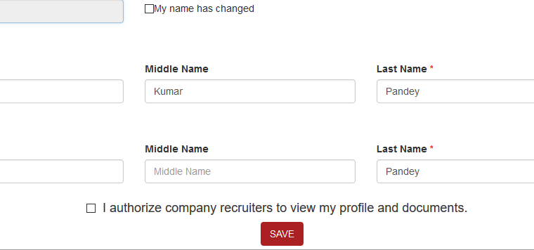

User must select the checkbox before clicking the ‘Save’ button. A pop-up message should appear to select, if checkbox not selected after ‘save’ button is clicked